TIPTOE comms pack
Intranet / newsletter copy
Are you aged 70+ and live with knee or hip joint pain?
You could be eligible to take part in a research study to help improve your quality of life.
The TIPTOE study run by Cardiff University and supported by Health and Care Research Wales, is looking into how well a personalised support programme can help with individuals living with pain in the knee and/or hip alongside other long-term conditions.
The study involves six one-to-one sessions with a trained healthcare practitioner, over six months held either face-to-face or online video call. It is advised participants take part with a nominated support person to help with navigating the study website and attend support sessions.
To find out more or to take part visit www.TIPTOE.org.uk or email TIPTOE@cardiff.ac.uk
__________________________________________________________________________________________________________________
Ydych chi'n 70 oed neu’n hŷn ac yn dioddef o boen yn y pen-glin neu gymal y glun?
Os felly, gallech chi fod yn gymwys i gymryd rhan mewn astudiaeth ymchwil i helpu i wella ansawdd eich bywyd.
Mae astudiaeth TIPTOE, sy’n cael ei chynnal gan Brifysgol Caerdydd a’i chefnogi gan Ymchwil Iechyd a Gofal Cymru, yn ymchwilio i ba mor effeithiol y gall rhaglen gymorth bersonol fod i’r unigolion hynny sy’n dioddef o boen yn y pen-glin a/neu gymal y glun, ochr yn ochr â chyflyrau hirdymor eraill.
Yn rhan o’r astudiaeth hon, bydd gofyn i chi gymryd rhan mewn chwe sesiwn un-i-un gydag ymarferydd gofal iechyd cymwys dros gyfnod o chwe mis, naill ai wyneb-yn-wyneb neu ar ffurf galwad fideo ar-lein. Y cyngor yw eich bod yn cymryd rhan gyda pherson a ddewiswyd gennych chi sy’n gallu eich helpu i lywio gwefan yr astudiaeth a dod i’r sesiynau cymorth.
I gael rhagor o wybodaeth neu gymryd rhan, gallwch chi fynd i www.TIPTOE.org.uk neu anfon e-bost at TIPTOE@caerdydd.ac.uk.

Social media content
Platform | English | Welsh | Image
Facebook | Are you aged 70+ and live with knee or hip pain?  You could be eligible to take part in a research study to help improve your quality of life.  The TIPTOE study, is looking into how well a personalised programme offering support from a trained professional can help you manage living with knee and /or hip pain alongside other long-term conditions.  The study involves six one-to-one sessions where you will be asked to record your progress over the course of 18 months.  To find out more or to take part visit www.TIPTOE.org.uk or email TIPTOE@cardiff.ac.uk | Ydych chi'n 70 oed neu’n hŷn ac yn dioddef o boen yn y pen-glin neu’r glun?  Os felly, gallech chi fod yn gymwys i gymryd rhan mewn astudiaeth ymchwil i helpu i wella ansawdd eich bywyd.  Mae astudiaeth TIPTOE yn ymchwilio i ba mor effeithiol y gall rhaglen gymorth bersonol gan weithiwr proffesiynol cymwys fod i’r unigolion hynny sy’n dioddef o boen yn y pen-glin a/neu gymal y glun, ochr yn ochr â chyflyrau hirdymor eraill.  Yn rhan o’r astudiaeth hon, bydd gofyn i chi gymryd rhan mewn chwe sesiwn un-i-un a chofnodi eich cynnydd dros gyfnod o 18 mis.  I gael rhagor o wybodaeth neu gymryd rhan, gallwch chi fynd i www.TIPTOE.org.uk neu anfon e-bost at TIPTOE@caerdydd.ac.uk. | 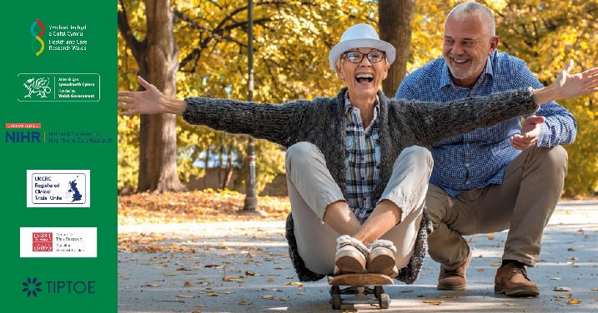
 | Do you know someone aged 70+ who lives with knee or hip pain?  They could be eligible to take part in a research study to help improve their quality of life.  The TIPTOE study, is looking into how well a personalised programme offering support from a trained professional can help those manage living with knee and /or hip pain alongside other long-term conditions.  The study involves six one-to-one sessions where you will be asked to record your progress over the course of 18 months.  To find out more or to take part visit www.TIPTOE.org.uk or email TIPTOE@cardiff.ac.uk | Ydych chi’n adnabod rhywun sy’n 70 oed neu’n hŷn ac yn dioddef o boen yn y pen-glin neu gymal y glun?  Os felly, gallen nhw fod yn gymwys i gymryd rhan mewn astudiaeth ymchwil i helpu i wella ansawdd eu bywyd.  Mae astudiaeth TIPTOE yn ymchwilio i ba mor effeithiol y gall rhaglen gymorth bersonol gan weithiwr proffesiynol cymwys fod i’r unigolion hynny sy’n dioddef o boen yn y pen-glin a/neu gymal y glun, ochr yn ochr â chyflyrau hirdymor eraill.  Yn rhan o’r astudiaeth hon, bydd gofyn i chi gymryd rhan mewn chwe sesiwn un-i-un a chofnodi eich cynnydd dros gyfnod o 18 mis.  I gael rhagor o wybodaeth neu gymryd rhan, gallwch chi fynd i www.TIPTOE.org.uk neu anfon e-bost at TIPTOE@caerdydd.ac.uk.
X / Twitter | Are you aged 70+ and live with knee or hip pain?  You could be eligible to take part in a research study to help improve your quality of life.  To find out more or take part visit www.TIPTOE.org.uk or email TIPTOE@cardiff.ac.uk  @ResearchWales @CTRCardiffUni @NIHRresearch | Yn 70 oed neu’n hŷn ac yn dioddef o boen yn y pen-glin/clun?  Cymerwch ran mewn astudiaeth i wella ansawdd eich bywyd.  I gael rhagor o wybodaeth neu gymryd rhan, ewch i www.TIPTOE.org.uk neu e-bostiwch TIPTOE@caerdydd.ac.uk.  @YmchwilCymru @CTRCardiffUni @NIHRresearch
 | Do you know someone aged 70+ who lives with knee/hip pain?  They could be eligible to take part in a research study to help improve their quality of life.  Find out more www.TIPTOE.org.uk or email TIPTOE@cardiff.ac.uk  @ResearchWales @CTRCardiffUni @NIHRresearch | Yn adnabod rhywun sy’n 70 oed neu’n hŷn ac yn dioddef o boen yn y pen-glin/clun?  Gallen nhw gymryd rhan mewn astudiaeth i wella ansawdd eu bywyd.  Ewch i www.TIPTOE.org.uk neu e-bostiwch TIPTOE@caerdydd.ac.uk.  @YmchwilCymru @CTRCardiffUni @NIHRresearch

